**WEEK-2**

**PL/SQL   
  
Mandatory Hands-on**

**Exercise 1: Control Structures**

**Scenario 1:** The bank wants to apply a discount to loan interest rates for customers above 60 years old.  
**Question**: Write a PL/SQL block that loops through all customers, checks their age, and if they are above 60, apply a 1% discount to their current loan interest rates.

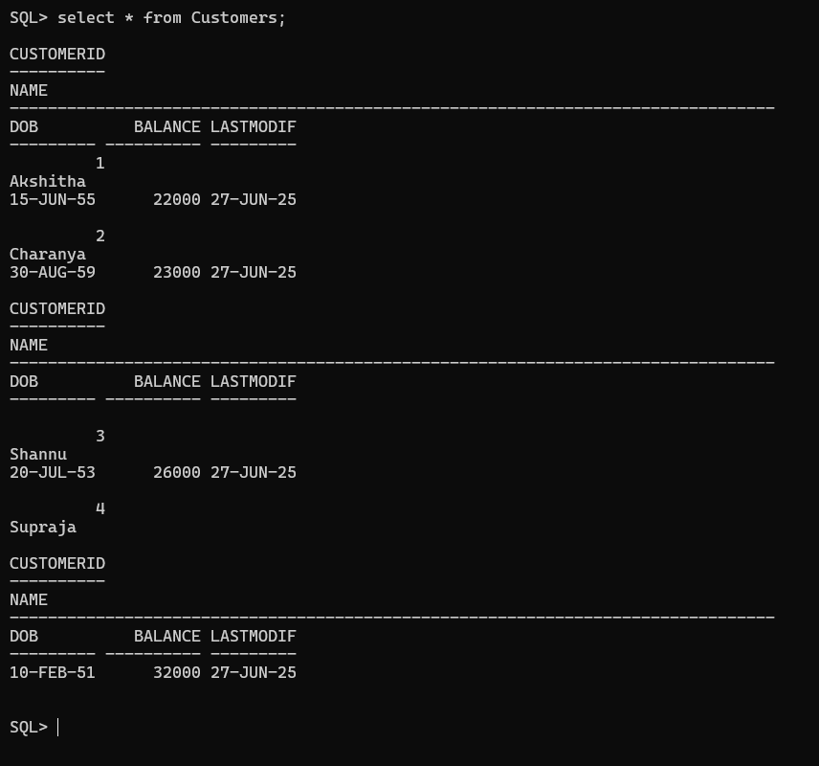  
  
BEGIN

FOR cust IN (

SELECT c.CustomerID, c.DOB, l.LoanID

FROM Customers c

JOIN Loans l ON c.CustomerID = l.CustomerID

) LOOP

-- Calculate age

IF MONTHS_BETWEEN(SYSDATE, cust.DOB) / 12 > 60 THEN

-- Apply 1% discount on interest rate

UPDATE Loans

SET InterestRate = InterestRate - 1

WHERE LoanID = cust.LoanID;

END IF;

END LOOP;

COMMIT;

END;

/  
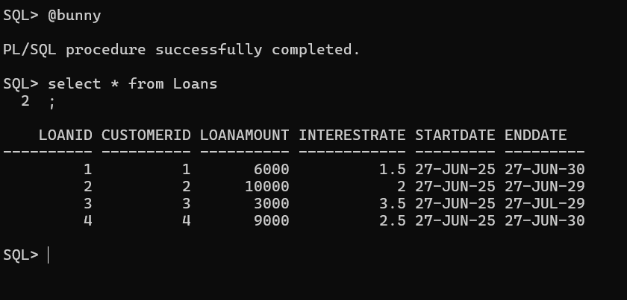  
  
**Scenario 2:** A customer can be promoted to VIP status based on their balance.

**Question:** Write a PL/SQL block that iterates through all customers and sets a flag IsVIP to TRUE for those with a balance over $10,000.

ALTER TABLE Customers ADD IsVIP VARCHAR2(5);  
BEGIN

FOR cust IN (

SELECT CustomerID, Balance

FROM Customers

) LOOP

IF cust.Balance > 10000 THEN

UPDATE Customers

SET IsVIP = 'TRUE'

WHERE CustomerID = cust.CustomerID;

ELSE

UPDATE Customers

SET IsVIP = 'FALSE'

WHERE CustomerID = cust.CustomerID;

END IF;

END LOOP;

COMMIT;

END;

/  
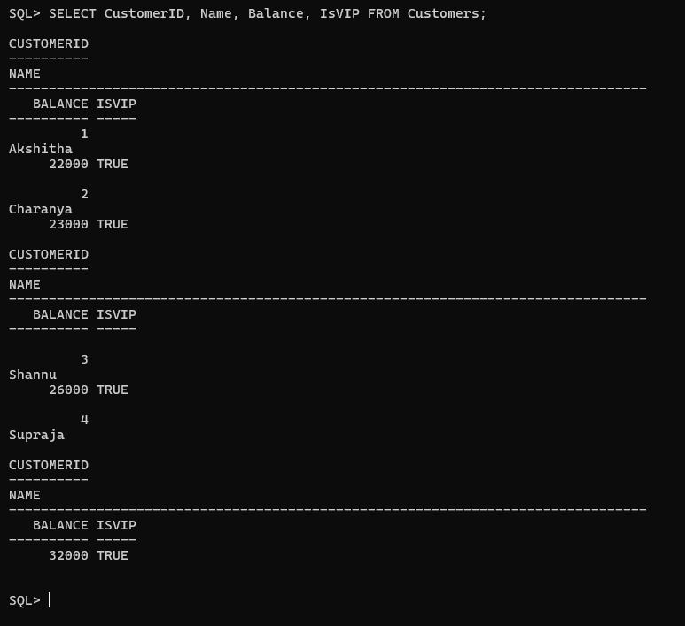  
  
**Scenario 3:** The bank wants to send reminders to customers whose loans are due within the next 30 days.

**Question:** Write a PL/SQL block that fetches all loans due in the next 30 days and prints a reminder message for each customer.

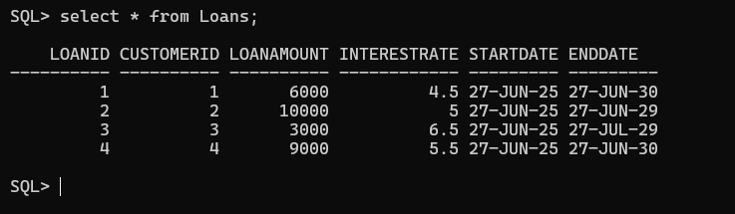

BEGIN

FOR loan_rec IN (

SELECT l.LoanID, l.CustomerID, l.EndDate, c.Name

FROM Loans l

JOIN Customers c ON l.CustomerID = c.CustomerID

WHERE l.EndDate BETWEEN SYSDATE AND SYSDATE + 30

) LOOP

DBMS_OUTPUT.PUT_LINE('Reminder: Loan ID ' || loan_rec.LoanID ||

' for customer ' || loan_rec.Name ||

' is due on ' || TO_CHAR(loan_rec.EndDate, 'DD-MON-YYYY'));

END LOOP;

END;

/  


**Exercise 3: Stored Procedures**

**Scenario 1:** The bank needs to process monthly interest for all savings accounts.

**Question:** Write a stored procedure ProcessMonthlyInterest that calculates and updates the balance of all savings accounts by applying an interest rate of 1% to the current balance.

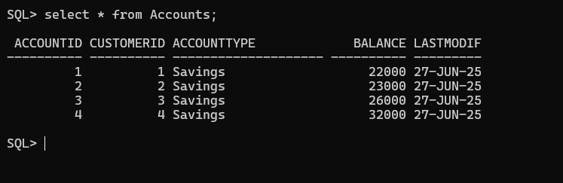

CREATE OR REPLACE PROCEDURE ProcessMonthlyInterest IS

BEGIN

FOR acc IN (

SELECT AccountID, Balance

FROM Accounts

WHERE AccountType = 'Savings'

) LOOP

UPDATE Accounts

SET Balance = Balance + (Balance * 0.01), -- Add 1% interest

LastModif = SYSDATE

WHERE AccountID = acc.AccountID;

END LOOP;

COMMIT;

END;

/  
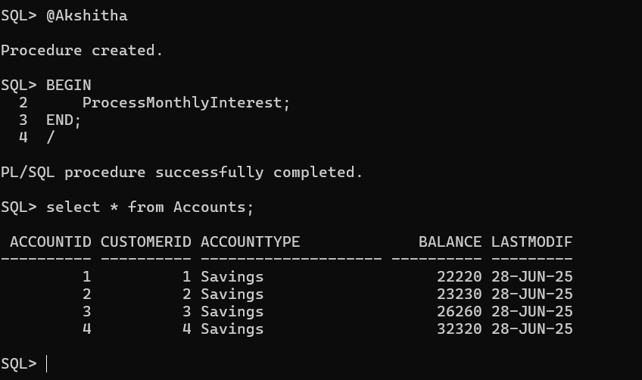

**Scenario 2:** The bank wants to implement a bonus scheme for employees based on their performance.

**Question:** Write a stored procedure UpdateEmployeeBonus that updates the salary of employees in a given department by adding a bonus percentage passed as a parameter.

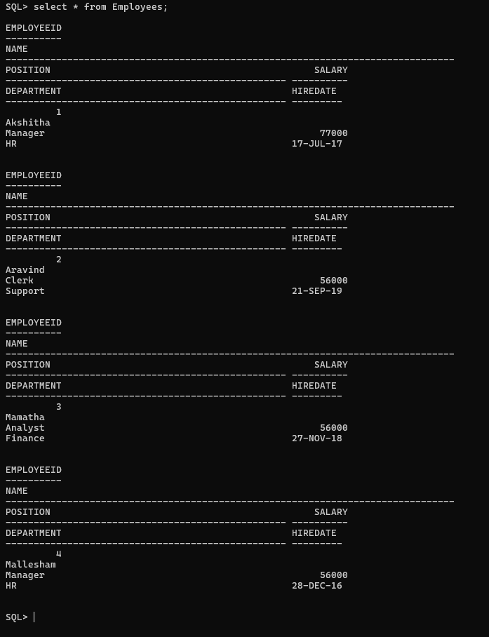

CREATE OR REPLACE PROCEDURE UpdateEmployeeBonus (

p_department IN VARCHAR2,

p_bonus_percent IN NUMBER

) IS

BEGIN

UPDATE Employees

SET Salary = Salary + (Salary * p_bonus_percent / 100)

WHERE Department = p_department;

COMMIT;

END;

/  
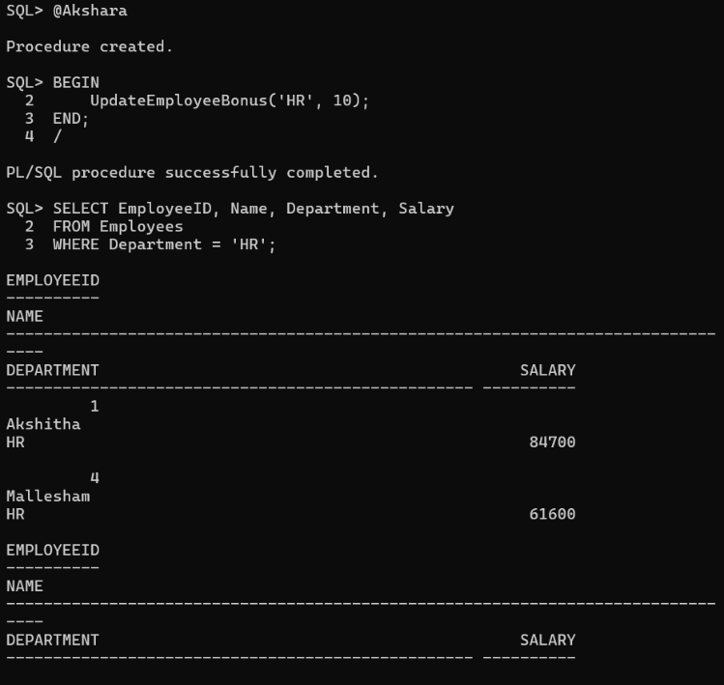  
  
  
**Scenario 3:** Customers should be able to transfer funds between their accounts.

**Question:** Write a stored procedure TransferFunds that transfers a specified amount from one account to another, checking that the source account has sufficient balance before making the transfer.  
  


CREATE OR REPLACE PROCEDURE TransferFunds (

p_from_account IN NUMBER,

p_to_account IN NUMBER,

p_amount IN NUMBER

) IS

v_from_balance NUMBER;

BEGIN

-- Get the balance of the source account

SELECT Balance INTO v_from_balance

FROM Accounts

WHERE AccountID = p_from_account;

-- Check if source account has enough balance

IF v_from_balance < p_amount THEN

RAISE_APPLICATION_ERROR(-20001, 'Insufficient balance in source account.');

END IF;

-- Deduct from source

UPDATE Accounts

SET Balance = Balance - p_amount,

LastModified = SYSDATE

WHERE AccountID = p_from_account;

-- Add to target

UPDATE Accounts

SET Balance = Balance + p_amount,

LastModified = SYSDATE

WHERE AccountID = p_to_account;

COMMIT;

END;

/  
  
